
Group#1

Okaz library
Software Requirements Specification (SRS)
Version: 1.0
CM Identifier: G1_SE02_v1.0

Revision History

Sl. No. | Prepared/  Modified by | E-mail | Version | Date | Approved by | Descriptions/  Remarks
1. | Mohamed Mayla | mohamed.mayla  @gmail.com | 1.0 | March 20, 2013 | N/A | Requirement specification
2. | Eslam Hashem | eslam.hashem7  @gmail.com | 1.0 | March 20, 2013 | N/A | Market survey
3. | Hagar Badr | hagar.bedr  @yahoo.com | 1.0 | March 21, 2013 | N/A | Introduction , high level plane
4. | Nada Karam | nada_karam23  @yahoo.com | 1.0 | March 21, 2013 | N/A | Cost estimate , feasibility study
5. | Mohamed Mayla | mohamed.mayla  @gmail.com | 1.0 | March 22, 2013 | N/A | NF correction
6. | Mohamed Mayla | mohamed.mayla  @gmail.com | 1.0 | March 29, 2013 | N/A | overall revision

Distribution list
Name | E-mail | Notes
Dr. Sayed Hemayed | hemayed@ieee.org | For approval
Eng. Omar Khaled | eng.oks@gmail.com | For approval

Table of Contents
1. Introduction 6
1.1 Purpose 6
1.2 Scope 6
1.3 Definitions, Acronyms and Abbreviations 6
1.4 References 7
1.5 Overview 7
2. Market Survey 7
2.1 Book Crossing 7
2.1.1 Project Description 7
2.1.2 Functional Specifications 7
2.1.3 Non-Functional Specifications 7
2.1.4 Limitations 7
2.2 Book Mooch 8
2.2.1 Project Description 8
2.2.2 Functional Specifications 8
2.2.3 Non-Functional Specifications 8
2.2.4 Limitations 8
2.3 Summary 8
2.3.1 Functional Specifications 8
2.3.2 Non-Functional Specifications 9
2.3.3 Limitations 9
3. Cost Estimate 10
4. Feasibility Study 10
4.1 Added Value 10
4.2 Technology, cost and time feasibility 10
5. Requirements Specifications 11
5.1 User Requirements (User Stories) 11
5.1.1 US01 – loan a book (2): 11
5.1.2 US02 – borrow a book (2): 11
5.1.3 US03 – sign in (for admin and managers) (2): 11
5.1.4 US04 – confirmation of loan/borrow book (2): 11
5.1.5 US05 – delete book from Okaz library (1): 11
5.1.6 US06 – notification list of borrower and loaner users (2): 11
5.1.7 US07 – list of all loaner users (1): 11
5.1.8 US08 – request code for users (1): 11
5.2 System Requirements (Use Cases) 12
5.2.1 Loan a book 12
5.2.2 Borrow Book 14
5.2.3 Confirm request 16
5.2.4 Borrower/loaners list 18
5.3 Non-functional Requirements 19
5.3.1 NFR01 19
5.3.2 NFR02 19
5.3.3 NFR03 19
5.3.4 NFR04 19
6. High level plan 20
7. Supporting Information 21

Software Requirements Specification

Introduction
This SRS is for Okaz Library, which is a website for Okaz activity on Cairo University to let them easily manage the book shared with peoples (students).

Purpose
The purpose of this SRS is to describe the Okaz library website. As the basic idea of the project is to manage sharing books between students and make it easy to managed with Okaz library managers (activity).
The website provide users (students) who want to loan a book to the library, easily upload the book cover (to make sure he has the book) with his name and phone number, after that he should deliver the book to the library managers, after that the book will appear on the website that is available to borrow.
The users (students) who want to borrow a book, should send request to borrow selected book from the website with his/her name and phone number, and then go the receive the book from the library for a certain time.
The manager of the Okaz library will manage all the above activities.

Scope
The scope of this SRS was discussed thoroughly by the team members developing this website with Okaz library activity managers. It’s was agreed upon that in the version 1.0 will have the full functionality of the website.
The system will provide the “smart confirmation code” feature that let managing all the activity by the managers more easy and fast, and the system will save the data on an online server.
The website will be ready to be published on the internet and ready to be used by the users.

The application will support simple use cases such as upload cover book, borrow a book and request confirmation by the managers with some complex use cases such as the generation of the “smart confirmation code” , the admin activity like delete a book.

Definitions, Acronyms and Abbreviations
HTTP: Hypertext Transfer Protocol
HTTPS: Hypertext Transfer Protocol Secure
IP: Internet Protocol
ASP.net: server-side Web application framework
HTML: Hyper Text Markup Language

References
- ASP.net:
http://www.asp.net

Overview
The rest of this SRS will contain some important information about the market surveys we carried on. The feasibility study we made, the cost estimate of and of course the traceability matrix of the project and our future plan.

Market Survey
In Cairo university Okaz library is the first web site for this purpose.
And such a project is rarely around the world wide.

But there is some of similar projects and we will show you why is the best using out web site rather than any other book sharing websites.

Book Crossing

Project Description
Share your book around the world and know its place.

Functional Specifications
- Registration is required:
Each user should register to use the website services
- Book crossing ID:
Users can print unique label for each book they have, and stick it in the cover of the book.
With this label users can track they books whatever they are.
- Users can know the place of they books, each time someone enter the book unique ID from the label on the website.

Non-Functional Specifications
- Website responds in less than 1 second (test done on speed 512 Mb).
- Have an easy interface; you can learn it in at least 5 minutes.

Limitations
- Need registration to use the website services
- It’s not an Arabic website (English interface)
- You can’t actually borrow a certain book
- You might lose your book

Book Mooch

Project Description
Community for exchanging used books; lets you give away books you no longer need in exchange for books you really want.

Functional Specifications
- Give & receive books: Every time you give someone a book, you earn a point and can get any book you want from anyone else at BookMooch. Once you've read a book, you can keep it forever or put it back into BookMooch for someone else, as you wish.
- Registration is required:
Users need to register an account to use the website services
- No cost needed of using website services
- Every time user enter a new book he get points, users can use this points to borrow books
- World wide
- Users can have wish list, the books you wish to borrow
- Users can review each other with feedback scores

Non-Functional Specifications
- Website responds in less than 1 second (test done on speed 512 Mb)
- Have an easy interface , you can learn it in at least 10 minutes

Limitations
- Need registration
- It’s not an Arabic website (English interface)
- You might lose your book if you borrow it to untrusted user

Summary
From the above information, we can see all the above websites don’t match the Egyptian people,
Because the language and not secure enough.
The most common advantage is those projects are universal around the world.
The most common disadvantage is they required sign-up to use the websites

Functional Specifications

Essential Specifications
- Each book marked with smart code (BCID) for easy recognizing
- Have the ability to borrow and receive books
- No cost (pay method)

Non-Essential Specifications
- Registration to use the website services
- World wide
- Wish list
- Score system

Non-Functional Specifications

Essential Specifications
- Website respond in less than 1 second in speed of 515 Mb
- Have an easy interface , you can learn it in at least 5 minutes

Non-Essential Specifications
- Have secure pay method

Limitations
From the above survey, all websites with English language and didn’t have secure way to make sure your book is safe.
Okaz managers can review and maintain the borrowing process and decrease the risk issue that come with the sharing process.

Cost Estimate
We gave it a good through of all the possible ways that we are going to spend money on, and we came up with a good plan that will help us minimize out cost estimate while maintaining the same level of sophistication to the project.

Item | Estimated Cost
Item | US Dollars | L.E.
1. Fixed Expenses
1.1. 4 PCs | 1195 | 8000
1.2. Printer | 53 | 350
1.3 Papers and Notes | 8 | 50
1.4 Electrical Appliances | 15 | 100
Total | 1271 | 8500
2. Monthly Expenses
1.1 Salaries | 597 | 4000
1.2 Office Rent | 112 | 750
1.3 Web server Hosting | 3 | 20
1.4 Domain Hosting | 2 | 13
Total | 117 | 783
Total Estimated Cost for first time | 1985 | 13283
Table 2: Cost Estimate

Feasibility Study

Added Value
- a lot of students buying books but that cost them a lot of money
- a lot of student have some books and finished reading them
- okaz library will provide a secure and trusted way to sharing books between students
- okaz library will encourage students to read and share books

Technology, cost and time feasibility
- After our market survey, such a web site doesn’t exist in our university
- Make it web application that will let the Okaz library spread on the university and between students and maybe will spread to the other universities
- The project team will make this project for free, that because the great value we will add to the community
- The website will be suitable to the most internet browsers and not need to add any plugin
- According to the time plan, the system won’t take much time to release

Requirements Specifications

User Requirements (User Stories)
Priority will range between 1 – 2, 2 for the most priority

US01 – loan a book (2):
Any user of the website can loan their books by uploading a cover photo for the book and write their name and phone number that will send a notification to the manager with your request and will show you the request code (the user should deliver it with the book).

US02 – borrow a book (2):
The users that want to borrow a book, by selecting a book from the website and click on borrow button, the website will ask the user to enter his/her name and phone number that will send a request to the manager and will show you the request code (the user should deliver it when receiving the book).

US03 – sign in (for admin and managers) (2):
Only the admin and manager can sign in to their registered accounts.

US04 – confirmation of loan/borrow book (2):
With the smart confirmation code system, manager can confirm that they receive or give a book to the user, with no human mistakes or errors and much more fast.

US05 – delete book from Okaz library (1):
Only admin can delete a book from Okaz library

US06 – notification list of borrower and loaner users (2):
Show a list with all current requests of the books and the end time of each

US07 – list of all loaner users (1):
List of all details of the users that loan a book in the library.

US08 – request code for users (1):
Each user can see current request codes they establish with the end time of it,
That can happen with entering the email and phone number as a security method to enter this page.

System Requirements (Use Cases)

Loan a book
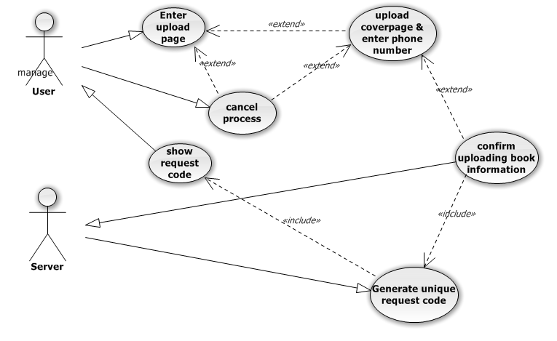

Name: Loan a book

Identifier UC01

Preconditions
- In home page
- Other website or page (user enter the upload page from URL).

Basic Course
- Use case begins when user enter the upload page
- User upload the cover image
- User type Name
- User type phone number
- User type email
- User press the confirm button
- Use case ends when system show the request code for the user

Alternate Course A: Description of the alternate course
Condition: The users leave the upload page
A.1. there is no image will saved
A.2. no data will be saved of the user
A.3. will reload the upload page with empty data boxes

Post conditions
- after the normal course:
The website will redirect you to the home page
- after alternate course A:
The website will redirect you to “uploading” page

Map to: US01

Borrow Book
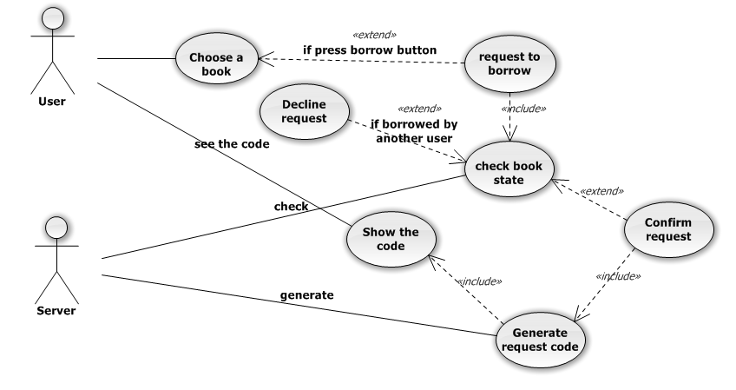

Name: borrow a book

Identifier UC02

Preconditions
- In home page
- Other website or page (user enter the book list page from URL)

Basic Course
- Use case begins when user enter the book list page
- User send request by click on borrow button
- User enter the request page for the book and write name
- User write phone number and email
- User press confirm button
- Use case ends when system show the request code for the user

Alternate Course A: Description of the alternate course
Condition: The users enter cancel button
A.1. there is no request will be sent
A.2. the book will still free to borrow by other user

Alternate Course B: Description of the alternate course
Condition: the book was borrowed by another user
B.1. there is no request will be sent
B.2. system will notify the user with this

Post conditions
- after the normal course:
The website will redirect you to the home page
- after alternate course A:
The website will redirect you to “book list” page
- after alternate course B:
The website will redirect you to “book list” page

Map to: US02

Confirm request
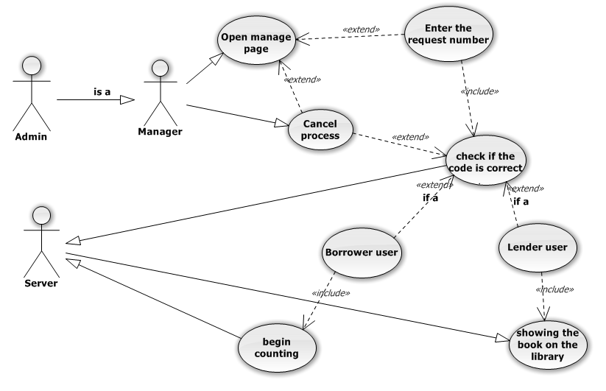

Name: confirm request

Identifier UC03

Preconditions
- Sign-in page
- Other website or page (user enter the sign in page from URL)

Basic Course
- Use case begins when admin/manager enter the manage page
- Manager/admin type in the request code
- Manager/admin press confirm
- The page will appear showing confirmation and request details like book name , cover page …etc
- Use case ends when system show the details page

Alternate Course A: Description of the alternate course
Condition: the request code is incorrect
A.1. system will show message with the error
A.2. will empty the box

Post conditions
- after the normal course:
The website will redirect you to the manage page
- after alternate course A:
The website will redirect you to the manage page

Map to: US04

Borrower/loaners list
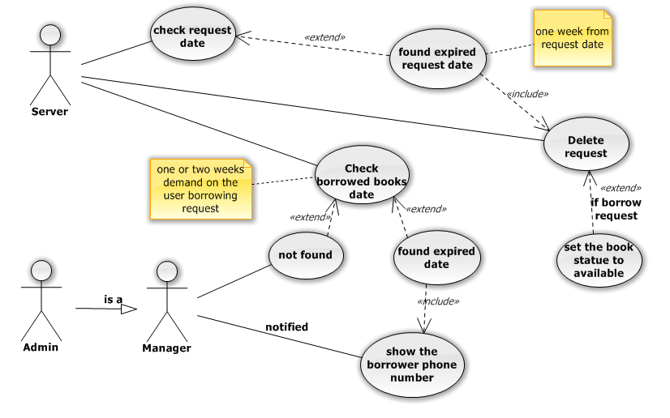
Name: borrower/loaner list

Identifier UC04

Preconditions
- Sign in page
- Other website or page (user enter the sign in page from URL)

Basic Course
- Use case begins when admin/manager enter the list page
- Press on the wanted list tab
- The list will appear
- Use case ends when system show list

Post conditions
- Same page (list page)
- Home page
- Other website

Map to: US06, US07

Non-functional Requirements

NFR01
The website shall has easy interface to the user so that he/she can easily borrow or loan a book, can learn the website in at most 5 minutes

NFR02
The website shall has high privacy for each user information, like phone number and email.
Note: users can’t see any other users information

NFR03
The website shall work probably on (Firefox, chrome, internet explorer, Opera)

NFR04
The system shall be light and fast (responds in at least 1 second) at speed 512Mb

High level plan

Task | Estimated Time
1.Putting SRS | 3 Days
2.Putting web page design | 1 Week
3.Putting software testing plan | 1 Week
4.Design the database | 3 Days
4Impliminting the website | 2 Weeks
5.Testing system | 1 Week
Total Time | 6 Weeks

Table 1: High Level Plan

Supporting Information

Traceability Matrix

RID | US01 | US02 | US03 | US04 | US05 | US06 | US07 | US08
UC01 | 
UC02 |  | 
UC03 |  |  |  | 
UC04 |  |  |  |  |  |  | 
NFR01 |  | 
NFR02 |  | 
NFR03
NFR04 |  |  |  | 

Dependability Matrix

RID | US01 | US02 | US03 | US04 | US05 | US06 | US07 | US08
US01 |  |  |  |  |  | 
US02 | 
US03
US04 |  | 
US05
US06 |  | 
US07
US08

